20. Blackmail Policies and Procedures
Sections:
- How do Owners Report Blackmail?
- Evidence Requirements
- Triage and Action Flow
- Review Processing
- Rare Scenarios: Blackmail vs. Incentives

"We take allegations of blackmail or threatening behavior by guests against property owners very seriously. This activity is strictly against our guidelines and may also be illegal in many locations."
— TripAdvisor Member Guidelines

How do Owners Report Blackmail?
Owners can report alleged blackmail in the following ways:
- Email: Write to blackmailreporting@tripadvisor.com, which feeds into Zendesk. When emailing this email, owners will receive and automatic email saying we do not accept preemptive reports and verbal threats. We will see the below message on the ticket:
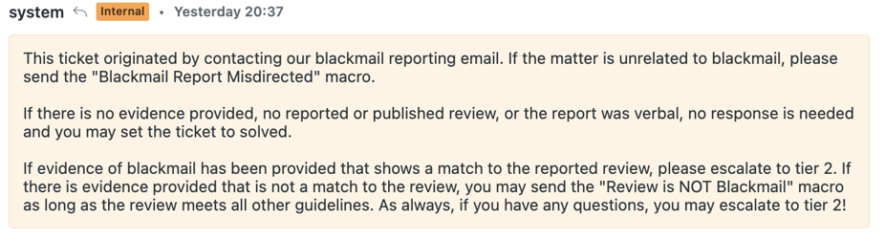
- Direct Email: Email contentintegrity@tripadvisor.com before or after a review is published.
- Owner Center Vote: Vote on an already published review via the Owner Center and replying to the voter template sent to them by the reported team.
Note on Preemptive Reports: Owners cannot report blackmail preemptively; there must be a review already on the live site for them to report it.

Evidence Requirements

Accepted Evidence
The owner must provide evidence that matches the specific review in question.
Note: Owners are informed before submission that evidence is required and must be of specific types. Reports without evidence or reports of verbal blackmail cannot be investigated.
- Acceptable Formats: Email, PDF, or screenshot of guest–owner correspondence supporting the blackmail claim.
- Unacceptable Formats: Property images, receipts/folios, witness testimonials/third-party reports, copy/pasted text, photos, video, or audio.

Evidence in Non-EN/IT/DE Languages
If the attachment is not in English, Italian, or German:
- If it is NOT guest-owner correspondence (e.g., a booking confirmation, handwritten note, or internal report):
  - Leave a comment noting that the attachment is not evidence of blackmail.
  - Send the "is NOT evidence" macro to the owner.
  - Set the ticket to solved.
- If it IS guest-owner correspondence: Have the entire conversation fully translated into English before escalating to Tier 2.

Triage and Action Flow

General Triage Flow
For reports that include evidence, follow this action table:
Situation | Action (Macro-based) | Owner Response
Blackmail with matching evidence | Escalate to Tier 2.
Blackmail with non-matching evidence | Send 'Review is NOT Blackmail' macro; solve ticket. | Inform owner review is not Blackmail.
Blackmail with incomplete or incorrect evidence format | Send "Is NOT evidence" macro and submit as pending. | Inform owner evidence format is invalid.
The report is unrelated to blackmail | Send 'Blackmail Report Misdirected' macro; solve ticket. | inform owner their enquiry is unrelated to Blackmail.
Verbal report or no evidence | Add internal comment; solve ticket. | Close the case, we don’t accept verbal threats.
Review is not published yet | Add internal comment; solve ticket. | Close the case, we don’t accept preemptive reports.
Review is not published yet and owner sends wrong evidence | Add internal comment; solve ticket. | Close the case, we don’t accept preemptive reports.
Owner contacts us emailing contentintegrity@tripadvisor.com rather than the right email address for BM. with a preemptive report | Add internal comment | Send “how to submit a blackmail report “ macro
Crucial Step: When a blackmail case involves any evidence, always ensure it is in the right format before escalating to Tier 2.
As always, if there are questions at any point or you need assistance, you may escalate the ticket to Tier 2.

Review Processing
Always evaluate all aspects of a review (text, photos, tips), including peripheral fraud, regardless of the queue. Investigate patterns in attributes and take appropriate action.
Situation | Action
Review is NOT blackmail. | Process per CMI moderation (text, photos, tips).
Re-submission: Prior review was removed for Blackmail (MF-Removed by T2). | Remove as Member Fraud: Blackmail. This applies only when prior reviews were MF-Removed by Tier 2, not for auto-removals.

Rare Scenarios: Blackmail vs. Incentives

Defining Blackmail vs. Incentives
Type | Definition | Initiator | Action/Penalty
Blackmail | User demands something (refund/upgrade) while threatening a negative review OR offering to remove a negative review if demands are met. | The user initiates the negotiation. | MF - blackmail removal, which penalizes the user's karma.
Incentives | Owner threatens the user or tries to convince a user to remove a negative review in exchange for something (refund, upgrade, future stay, etc.). | The owner initiates the negotiation. | Penalizes the location in the pop index and results in a Fraud Letter.

Parallel Conversations
When a user claims the owner offered incentives and the owner claims the user blackmailed them:
- Do not merge these tickets; treat them as two separate conversations.
- Determine who initiated the negotiation (Blackmail or Incentives).
- Ask both the owner and the user for the entire conversation/evidence.
- Once documentation is received, escalate both tickets to T2.
- Leave internal comments on both tickets referencing the other ticket/conversation.

Owner Doesn't Respond to Evidence Request (Resubmission Scenario)
If the owner does not respond but the review violates moderation guidelines (in a resubmission scenario):
- No need to respond to the owner.
- If the ticket is not solved, close it without a response to the owner.
- Action: Leave an internal comment stating the review was removed, along with the relevant moderation removal reason.
- Remove the review with the correct removal reason.

